**PHYS 101 - Measurement and Uncertainty in Scientific Experiments**

19.5/34

**Worksheet**

*Complete the worksheet as a group and turn in a single document with your names.*

Colin Finney Lauren Crane

Andrew Manns

*Show all work and calculations to receive full credit! You may use additional sheets.*

1. Significant Figures
   1. Suppose you are measuring the mass of a pendulum bob on an electronic mass balance. The mass balance reads “10.4 g”. How many significant figures does this reading have?

3

2/2

* 1. What is the relative uncertainty of this measurement, expressed as a percent error? (recall that the precision of an electronic instrument is usually equal to the smallest difference it can detect, 0.1 g in this case)

10.4 +- 0.1

0/3; relative uncertainty is 0.1/10.4 * 100%

* 1. Suppose you measure the mass with a more precise electronic mass balance, that can measure mass with a precision of 0.01 g. If the mass balance reads “10.40 g”, how many significant digits are there? Write this value so that the number of significant digits is not ambiguous.

0/3; 4 sig figs, write in scientific notation: 1.040*10^1 g

3

10.4

1. Propagation of Uncertainty

You are asked to measure the volume of a spherical object. Knowing that the volume, V, is related to the radius, R, by $V=\left(4/3\right) π R^{3}$, you measure the radius to be 2.2 cm ± 0.1 cm.

* 1. Convert the measurement of the radius to meters and express the radius in scientific notation.

2/2

m.

* 1. Calculate the volume of the sphere (in cubic meters) using the measured radius and determine the **maximum relative uncertainty**.

3.5/5; uncertainty not right

$V=\left(4/3\right) π R^{3}$,

$$V=\frac{4}{3}*π*{\left(2.2*{10}^{-2}\right)}^{3}m$$

$$V=4.46*{10}^{-5}m^{3}$$

**Maximum relative uncertainty**:

* 1. You now calculate the volume of a cylindrical object. The height is measured to be 5.2 cm ± 0.05 cm and the radius is measured to be 2.5 cm ± 0.05 cm. Calculate the volume and the **maximum relative uncertainty** of the volume calculation.

Maximum Relative Uncertainty = 2(delta r / r)

0/5; need to compute ∆V/V

$MaxUncertainty=2(\frac{.1}{2.5})$ = .08

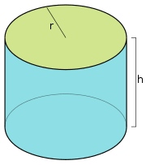

1. Statistical Errors

12/14 total

*Watch “Video 4 – Ramp Experiment” before doing these exercises*

Your use a compressed spring to launch a wheeled cart up an inclined ramp (see video). We wish to know how far the cart is launched up the ramp, and this displacement can be measured using the ramp’s built-in ruler. The starting position of the cart is measured, and the displacement is then the difference between the starting and ending positions. To determine the precision of this measurement, you repeat and record your measurements 10 times.

Use the data to report an **average value** of the displacement and calculate the **standard deviation** and **standard error** in this value. Convert your standard error to a **percent error.** If you use Excel or some other program to automate these calculations, please include the Excel file or a screenshot of your work.

DATA:

|  |  |  |
| --- | --- | --- |
| Trial | End position (cm) | Displacement (cm) |
| 1 | 44.1 | 10.9 |
| 2 | 44.5 | 11.3 |
| 3 | 44.4 | 11.2 |
| 4 | 44.9 | 11.7 |
| 5 | 43.8 | 10.6 |
| 6 | 44.2 | 11.0 |
| 7 | 46.9 | 13.7 |
| 8 | 44.1 | 10.9 |
| 9 | 44.8 | 11.6 |
| 10 | 44.4 | 11.2 |

Average Value = 11.41

Standard Deviation = 0.825

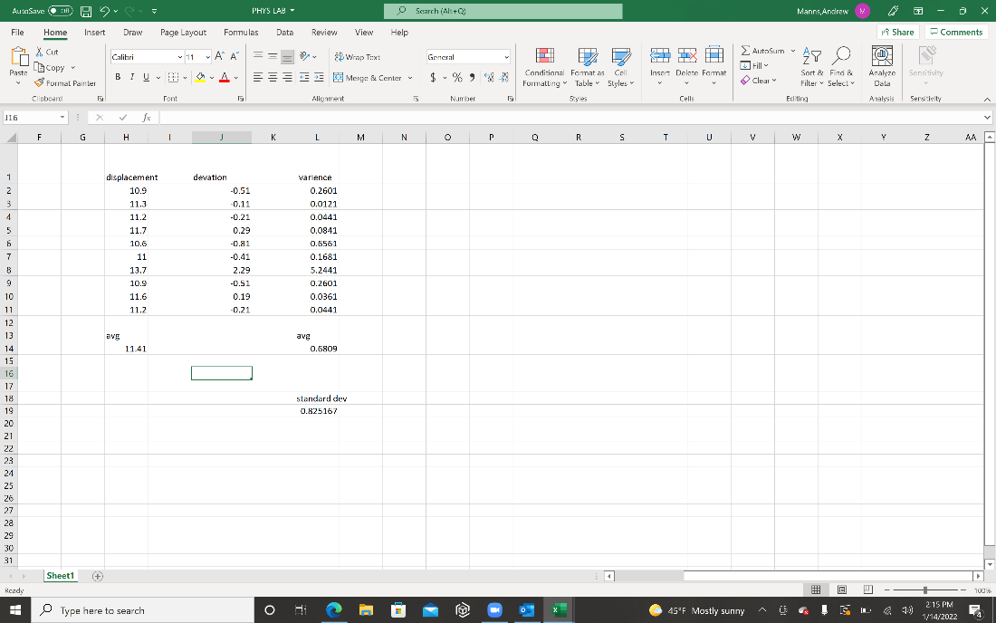

Standard Error = 0.276

-2; = stderr/avg * 100%

Percent Error =

* 1. Comment on the “spread” of the data and what it says about the precision of your measurements.

Due to how high the calculated percent error is and the wide spread of numbers, the conclusion can be made that the data collected is not very precise.

* 1. Identify specific sources of uncertainty in this experiment. Then, suggest some ways to reduce uncertainty and improve the precision.

The sources of uncertainty of this experiment could be neglected air resistance and friction of the cart’s wheels against the track. Uncertainty could also stem from the precision of the tools used to measure the cart's final displacement. A more in-depth measurement tool could lead to better data. This could have narrowed our spread of data and led to a smaller standard deviation and percentage error.